|  |  |  |  |  |  |
| --- | --- | --- | --- | --- | --- |
| Date | 7-Dec-22 | | | Tester Name | Richard Belanger |
| Environment | Penfax - Test | | | Login used | Test 2 |
| Operating System | Windows | Version: | Update: | | |
| Software Used | Edge | Version: | Update: | | |
| Select Software | Version: | Update: | | |
| Release version | 22.4.1 | | | | |
| Title | M28.04 Print off a T4 for the member | | | | |
| Test Type | Regression | | | | |
| Test Scenario | Print off a T4 for the member | | | | |
|  |  | | | | |
| Expected Results | The document will be printed | | | | |
| Pass/Fail | Pass | | | JIRA# | N/A |

Describe your steps with screenshots:

Member had retired in 2022

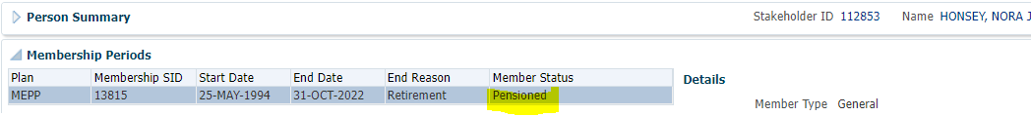

Payment History

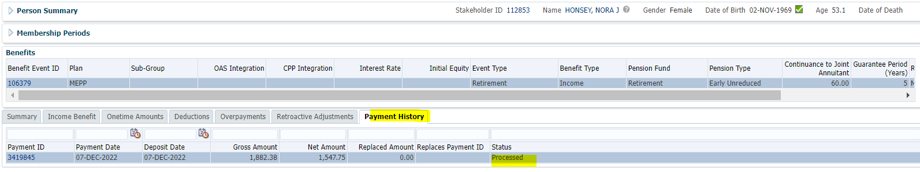

Person Profile>Communication>Click Filename for the T4A

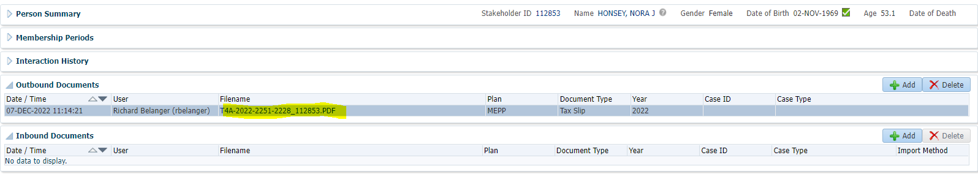

Tax Slip Produced

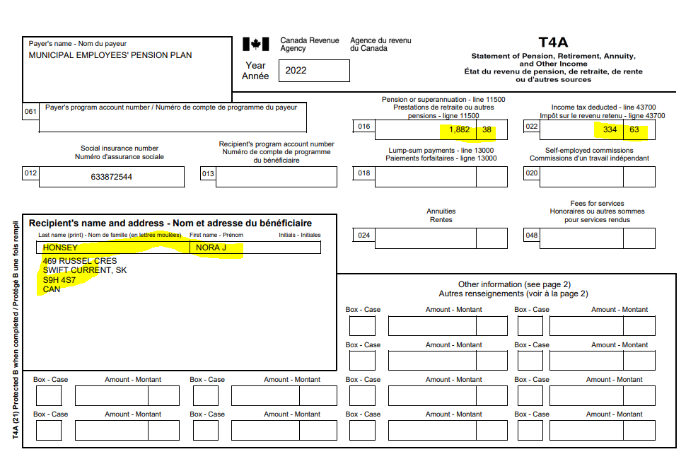

Print the document

